**3.1.1.Pre-requisites for Dedicated Interconnect to On-Premises DC’s :**

o On-Prem IP ranges which would connect to GCP over the Dedicated Interconnect

**3.1.2.Steps to follow for setting up Dedicated Interconnect to On-Premises DC’s(QDC & TDC)**

Order Dedicated Interconnect Links:

1. Order 4 links (2 each for us-east & us-west) according to the Technical Design Document (TiDD) manually in the console.  
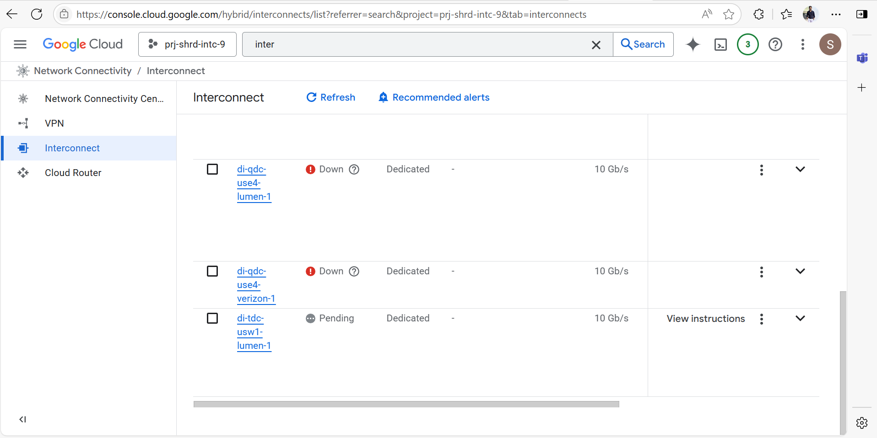  
2. Retrieve LOAs (Letter of Authorization) and share them with the Telco Provider (Lumen & Verizon) .

3. Wait for the link to be up and test the link.

Google Cloud Configuration:

4. In Project :- prj-shrd-ntwk-3, Create Cloud Routers in Google Cloud with VPC/Network:- vpc-hub-external and Region:- us-east4.

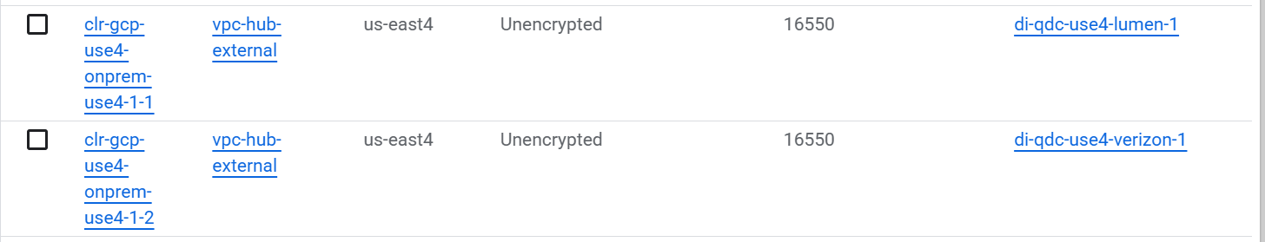

5. Create VLAN attachments for us-east4 in Project :- prj-shrd-ntwk-3 using steps mentioned in GCP Document . Using option :- To use connections in another project, select In another project, and then enter the Project ID:- prj-shrd-intc-9 of the project.

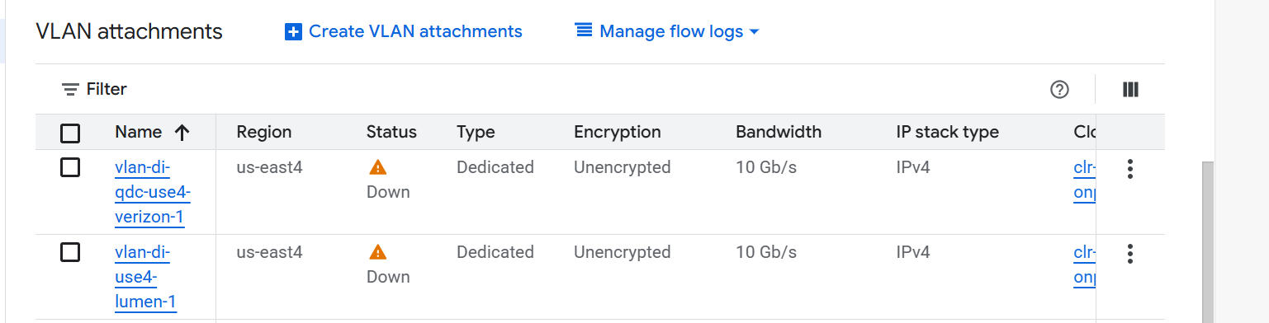

6. Configure the on-premises router using steps mentioned in GCP Document.

7. Configure MACsec using steps mentioned in GCP Document.  
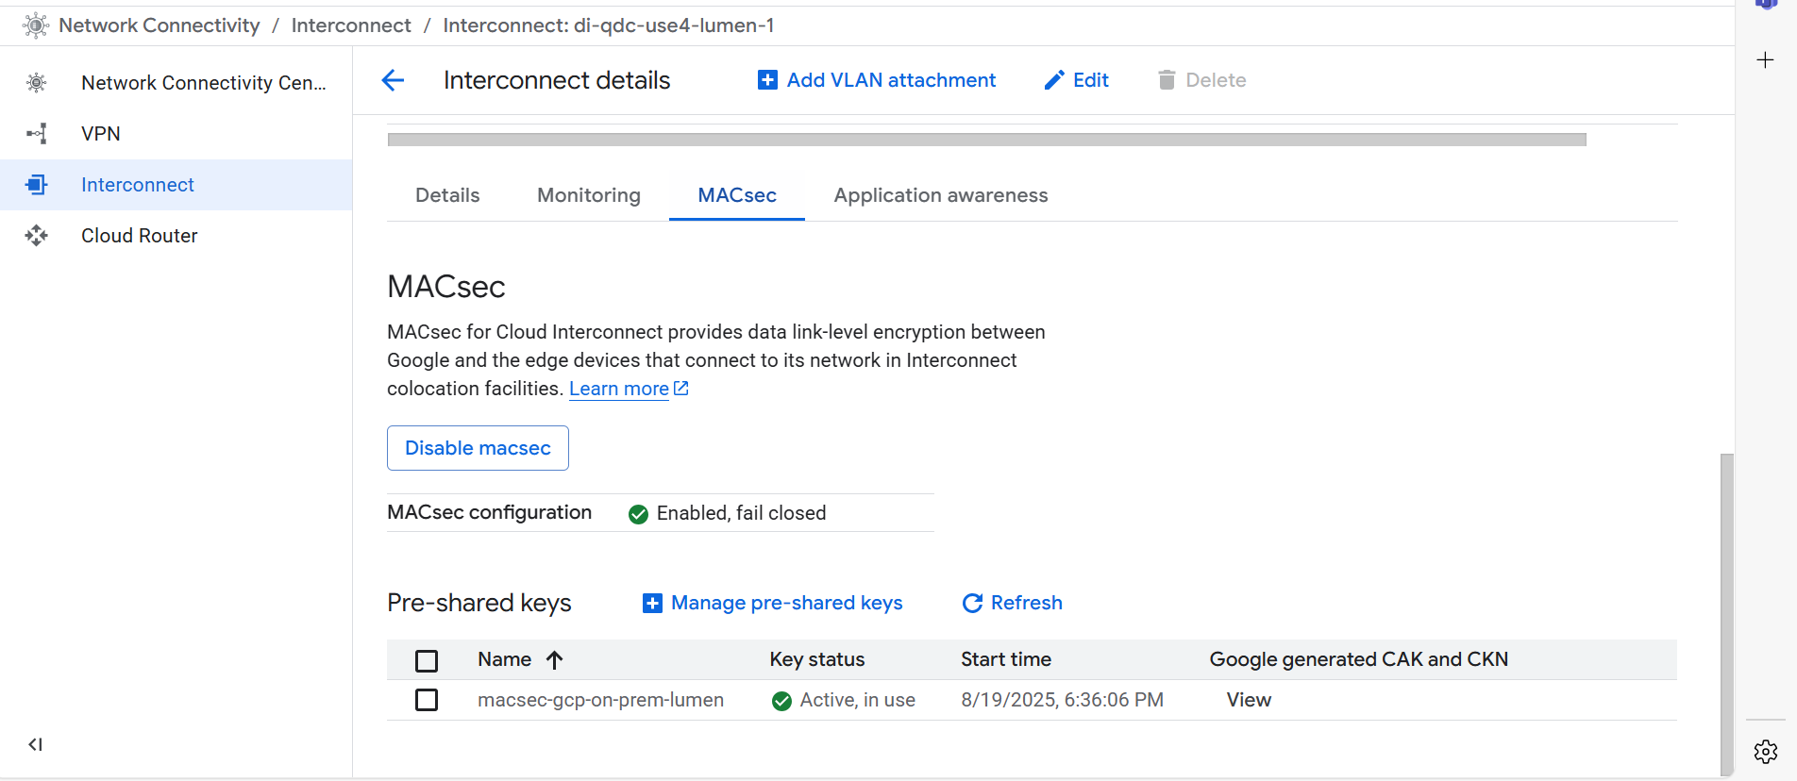  
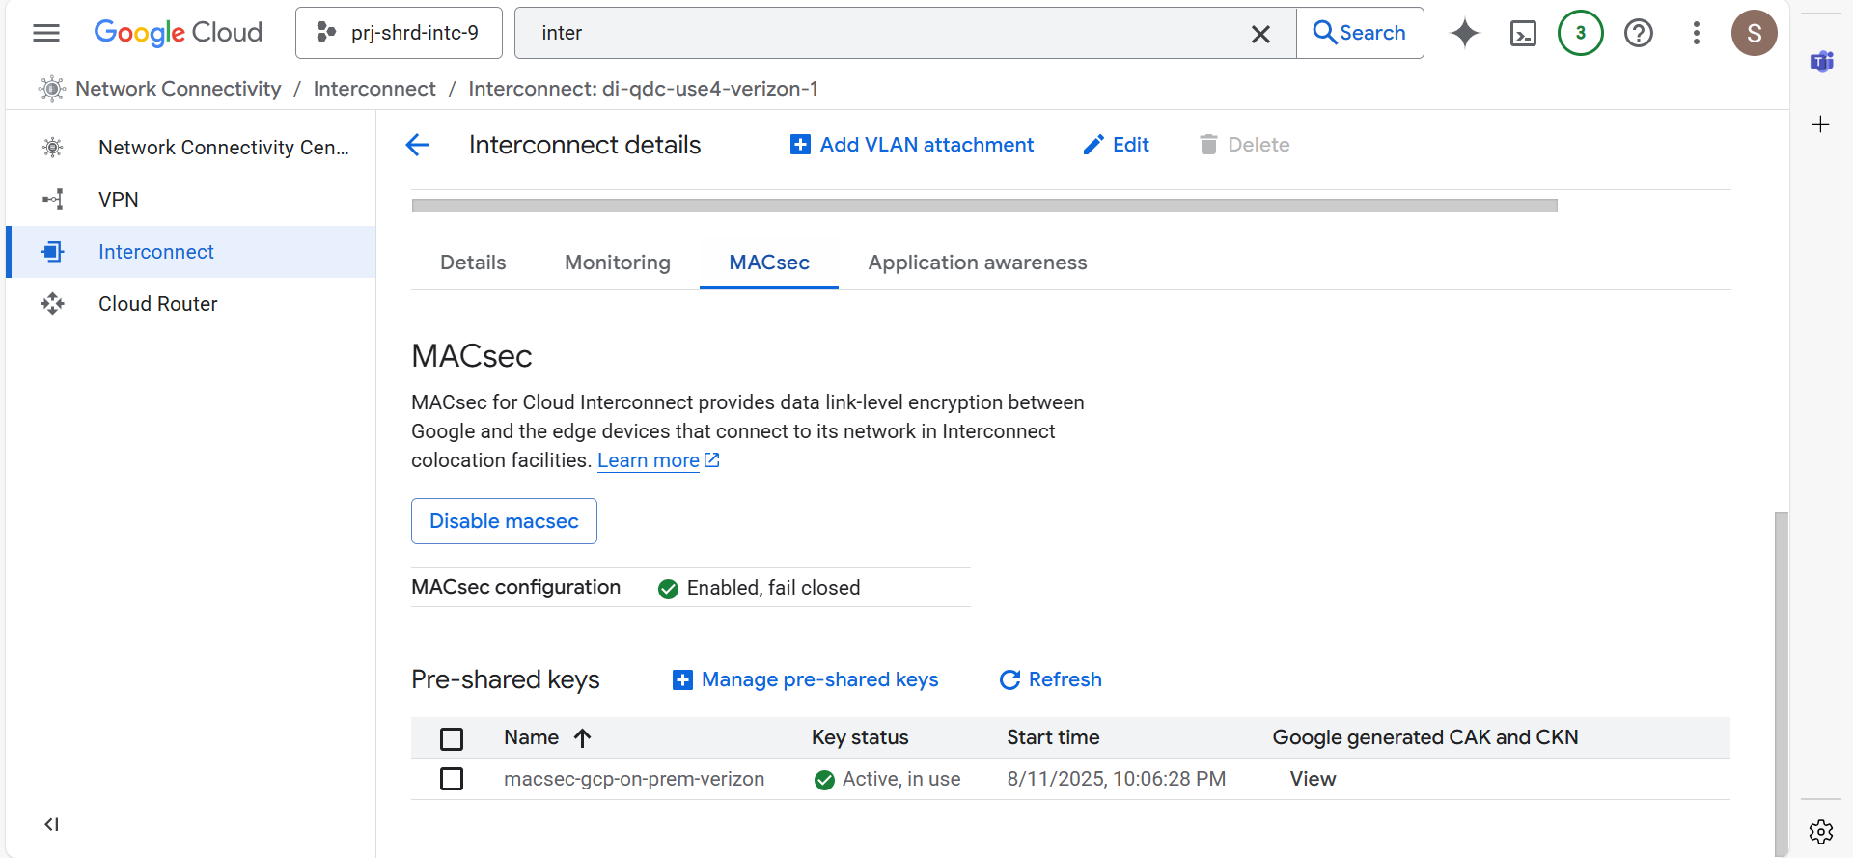

Repeat the steps 4 to 7 for the second Dedicated Interconnect connection pair for region (us-west1).

When we create the second set of VLAN attachments for the second Dedicated Interconnect connection pair, specify a second region (us-west1) with another Cloud Router.